CUSTOMER & MVP BLUEPRINT
Farm Equipment Rental Platform for Smallholder Farmers, India
Source: Startup Validation Report (Sidh, June 22, 2026) · Built for: rapid MVP scoping

Executive Summary
The underlying problem — unaffordable mechanization for India's 125M+ small/marginal farmers — is real and severely under-served by ownership. But the rental category already has an OEM-backed leader (Trringo), a VC-funded challenger (EM3), and a free government alternative (CHCs). The path to product-market fit is not a generic rental app: it is a narrow, trust-first wedge (single district, WhatsApp/voice-first booking, verified operators) that out-executes incumbents on density before competing on brand. This blueprint translates that conclusion into a buildable, 30-day-testable MVP.

Ideal Customer Profile
Attribute | Demand-side (Renter) | Supply-side (Owner)
Profile | Small/marginal farmer, <2 ha, UP/Bihar/MP/Maharashtra | Medium farmer/contractor, 1–2 tractors, 4–10 ha capacity
Need | Affordable, on-time access to machinery for 2–3 critical windows/year | Monetize idle equipment between own usage windows
Digital access | Shared/basic smartphone, WhatsApp-literate, app-shy | Slightly higher literacy; comfortable with calls/WhatsApp

Buyer Persona — “Ramesh”
Attribute | Detail
Age / Location | 42, small village, eastern Uttar Pradesh
Land & Crop | 1.2 ha; wheat (rabi) + paddy (kharif)
Today's workaround | Borrows a neighbor's tractor or calls a known local contractor
Trust driver | Neighbor word-of-mouth beats any ad
Critical moment | 7–10 day sowing/harvest window — availability beats price at the margin

Top 10 Customer Pain Points
# | Pain Point
1 | Equipment unavailable exactly when needed — demand spikes hard at sowing/harvest
2 | No price transparency — contractor rates negotiated case-by-case, often inflated
3 | No verified operator standard — skill and equipment-damage risk
4 | Long distance to nearest CHC or reliable contractor in remote villages
5 | No fallback if booked equipment breaks down mid-task
6 | Cash-only, informal payment — no receipts, no recourse
7 | Low trust in digital/online payment for an unseen service
8 | Existing informal relationship with a known contractor is sticky
9 | Free/subsidized government CHC sets a near-zero price anchor
10 | Low personal digital literacy — app perceived as “for my son, not me”

Customer Journey
Awareness | Consideration | Purchase | First Use | Retention
Village agent/neighbor mentions service | Compares price vs. contractor & CHC | Books one low-stakes job via WhatsApp/call | Judges punctuality, operator skill, fair price | Repeats next season; refers, or churns on any failure
Pivotal moment: “First Use.” One late arrival or price surprise likely causes permanent churn back to the informal system.

Key Customer Objections & Buying Triggers
Objections | Buying Triggers
“This app is for my son, not me”  “I don't trust paying online”  “What if the tractor doesn't show up?”  “The CHC is free — why pay you?”  “I already have a guy I call” | Sowing/harvest season approaching  Neighbor's positive word-of-mouth  Crop-sale / loan-disbursement cash availability  CHC at capacity / unavailable  Govt. scheme awareness drives

MVP Recommendation

Build first
- A WhatsApp/voice-call booking flow (no app) for ONE district — dispatcher matches farmer requests to nearby listed equipment manually.
- A simple owner-side intake (phone + spreadsheet/CRM) to list tractors/implements and availability windows.
- A basic operator verification checklist (ID, experience, reference) — the trust layer that's weakly standardized industry-wide.

Do NOT build yet
- A native mobile app — premature until WhatsApp/voice MVP proves repeat bookings.
- Owned equipment fleet — stay asset-light; never buy tractors directly.
- Multi-state expansion, financing/insurance products, or IoT tracking — all valid later, not now.

Success metrics (first 30 days)
Metric | Target
Completed bookings | ≥ 15 paid bookings in pilot district
Repeat usage | ≥ 25% of farmers book a 2nd time within the window
Referral signal | ≥ 3 bookings sourced from word-of-mouth, unprompted
Unit economics | Positive contribution margin per booking after dispatcher time

MoSCoW Prioritization
Priority | Items
Must Have | WhatsApp/call booking flow  Owner equipment listing (manual)  Basic operator verification  Cash + simple digital payment receipt
Should Have | Booking confirmation SMS  Simple price-list transparency by task/hour  Dispatcher dashboard (spreadsheet-based)
Could Have | Lightweight native app (post-validation)  Ratings/reviews for operators  Multi-district dispatcher view
Won't Have (now) | Owned equipment fleet  Financing/insurance products  IoT equipment tracking  Multi-state launch

Pricing Hypothesis
Commission-based marketplace take-rate of 8–12% on each booking's transaction value, paid by the equipment owner (not the farmer) to keep the farmer's price competitive with informal contractor rates and close to CHC pricing. Validate willingness-to-pay directly in farmer interviews — do not assume the rate; test 3 price points during the pilot.

Top 5 Risks
Risk | Likelihood | Impact | Mitigation
Incumbent competition (Trringo/EM3/CHC) | High | High | Win one district fully before expanding
Low app/digital adoption | High | Medium | WhatsApp/voice-first, no app at MVP stage
Thin unit economics | High | High | Density-first rollout; bundle services to raise basket size
Operator/equipment liability | Medium | High | Operator verification + basic insurance partner
Seasonal demand concentration | Medium | Medium | Diversify crop/equipment mix over time

30-Day MVP Plan
Week | Focus
Week 1 | 25–30 farmer interviews in one district; validate spend, frustration, willingness to pay
Week 2 | 10–15 equipment-owner interviews; mystery-shop CHC/Trringo/local contractor pricing
Week 3 | Launch WhatsApp/call booking MVP; run real, paid pilot bookings in one village/cluster
Week 4 | Measure bookings, repeat rate, referrals, unit economics; make the Go/No-Go call

Founder Action Sheet — Top 10 Next Actions
# | Action
1 | Pick ONE pilot district with high small-farmer density and weak digital-platform coverage
2 | Conduct 25–30 farmer interviews in person — validate spend and pain, not just interest
3 | Conduct 10–15 equipment-owner interviews — confirm supply-side willingness to list
4 | Mystery-shop Trringo, EM3 (if present), and the local CHC for real pricing/turnaround
5 | Set up a WhatsApp Business number + simple spreadsheet dispatcher system
6 | Define and test 3 commission price points with real bookings
7 | Recruit and verify 5–10 equipment owners as initial pilot supply
8 | Run 15+ real paid bookings in the pilot window
9 | Track repeat-booking and referral rate weekly
10 | Decide Go/No-Go on building a native app based on real pilot data, not assumptions

Scores (0–100)
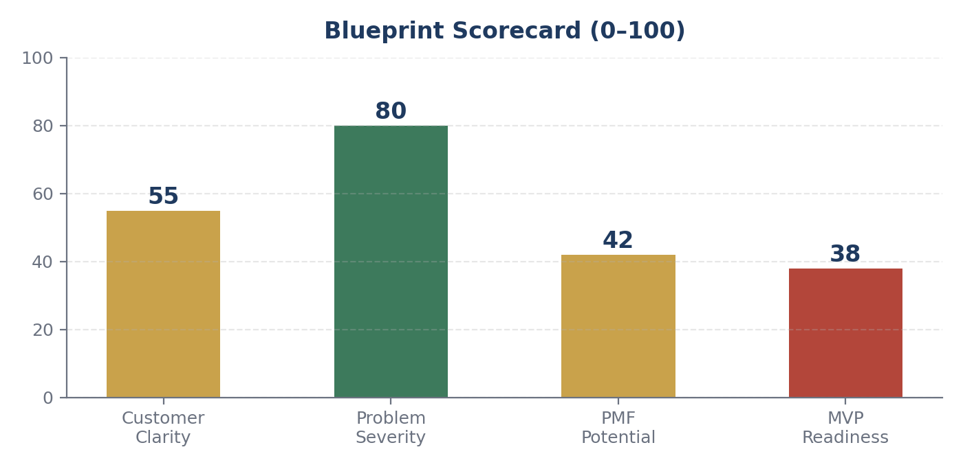
Customer Clarity, Problem Severity, PMF Potential, MVP Readiness.
Score | Value | Why
Customer Clarity | 55 | ICP and persona are well-defined from secondary data; zero direct interviews yet
Problem Severity | 80 | Extensively documented structural problem, decades-old, not assumed
PMF Potential | 42 | Real demand, but crowded with strong incumbents — fit depends entirely on finding a wedge
MVP Readiness | 38 | No interviews, no pilot, no supply-side commitments secured yet

Final Verdict
🟡 PROMISING BUT UNVALIDATED
The problem is severe and well-documented, but customer clarity, PMF potential, and MVP readiness all sit in the mid-to-low range because no direct farmer or equipment-owner validation has happened yet. This is a promising idea that needs the 30-day plan executed — with a clear wedge identified — before any code or capital commitment.

